**Task 1: Launch an EC2 Instance & Modify Volume Size (Vertical Scaling)**

### ****Step 1: Launch an EC2 Instance****

1. **Log in to AWS Academy** → Navigate to **EC2 Dashboard**.

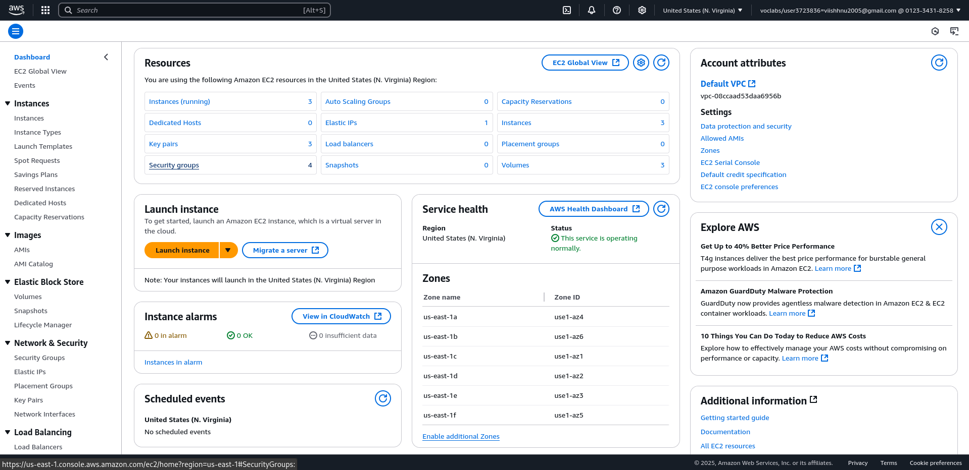

1. Click on **Launch instance** and configure:
   * **AMI (Amazon Machine Image)**: Choose **Amazon Linux 2** or **Ubuntu**.

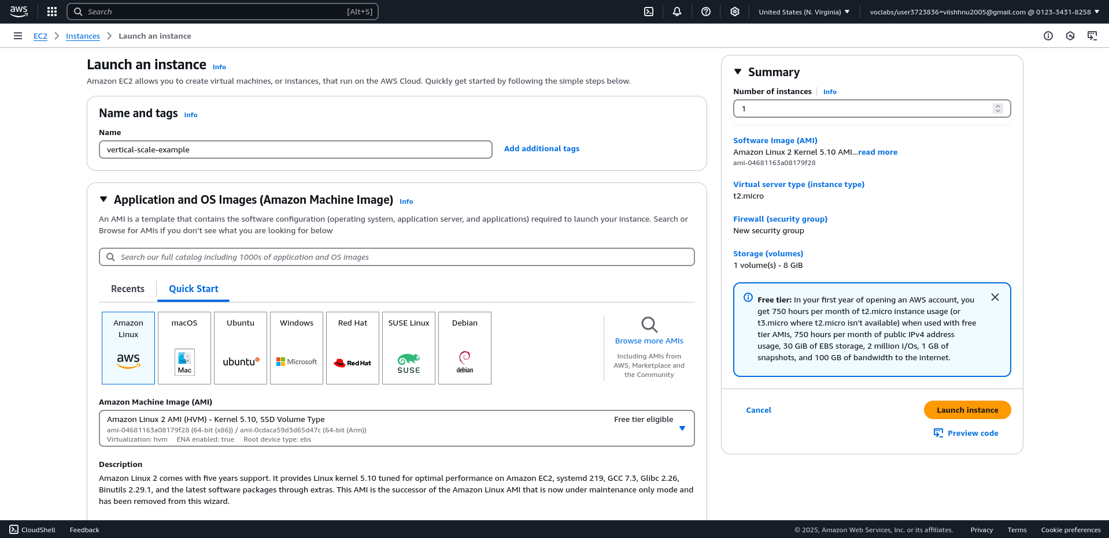

**Instance Type**: Select a type available in AWS Academy (e.g., t2.micro).

* + **Key Pair**: Create a new key pair or use an existing one.
  + **Storage**: Default EBS volume is created.
  + **Security Group**: Allow SSH (port 22) to connect via terminal.

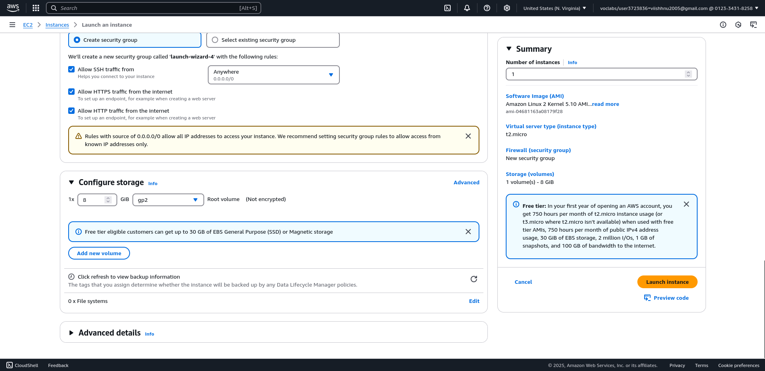

1. Click **Launch Instance** and wait for it to be ready.

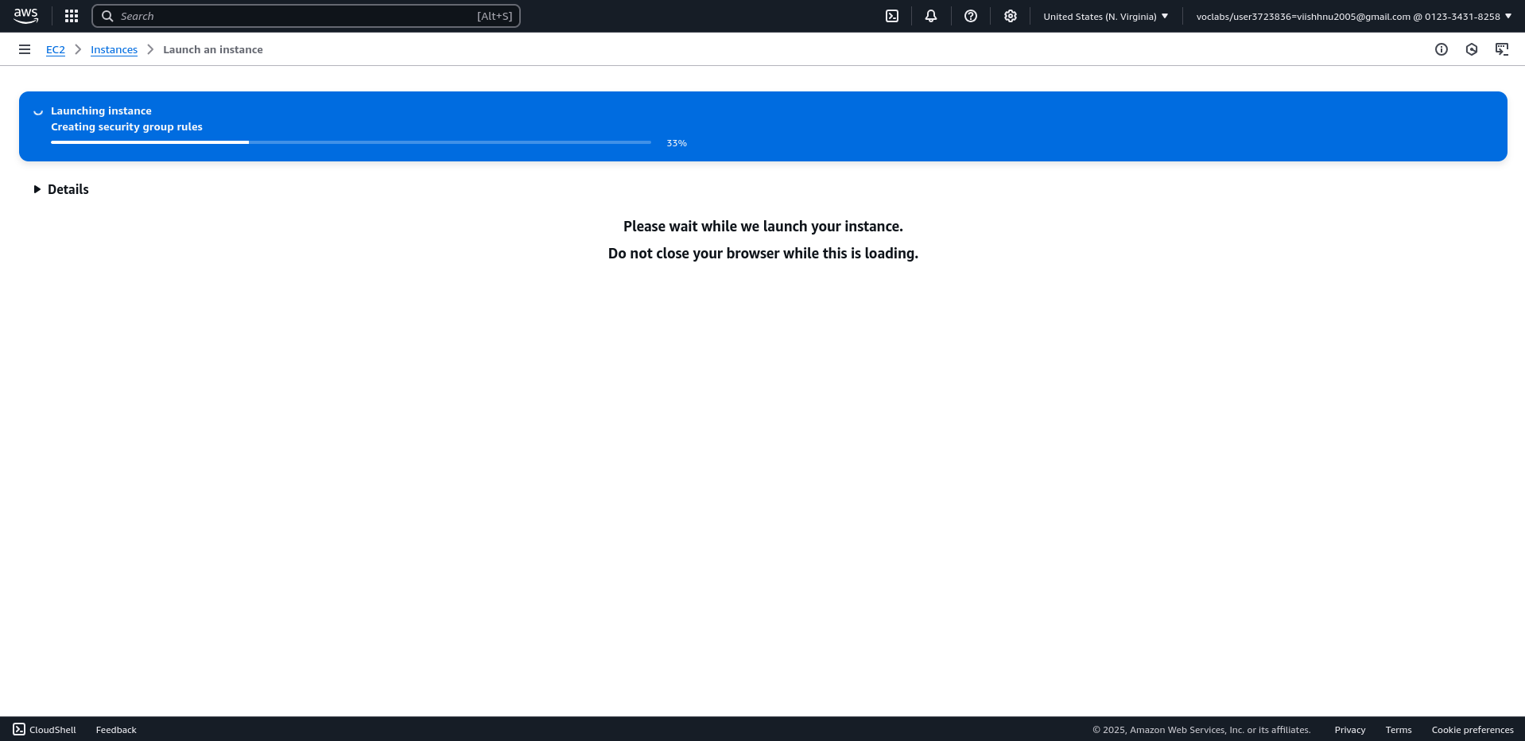

### ****Step 2: Check Volume Size & Modify (Vertical Scaling)****

1. In the **EC2 Dashboard**, go to **Volumes** (under Elastic Block Store).

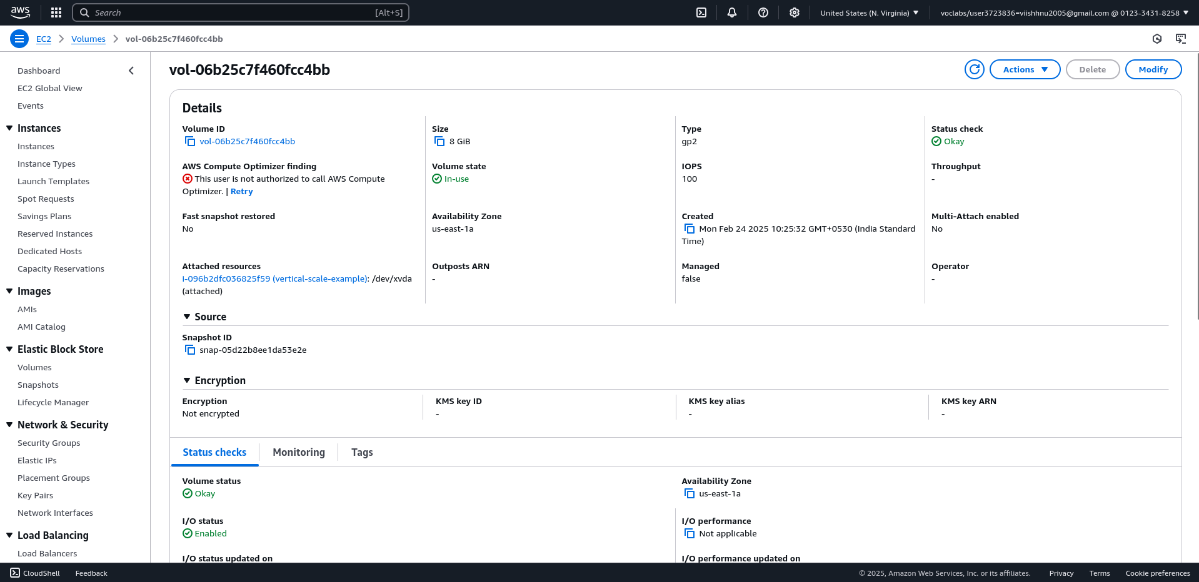

1. Select the volume attached to your instance.
2. Click **Modify Volume** → Increase the size (e.g., from 8GB to 16GB).
3. Click **Modify** → AWS will resize the volume.

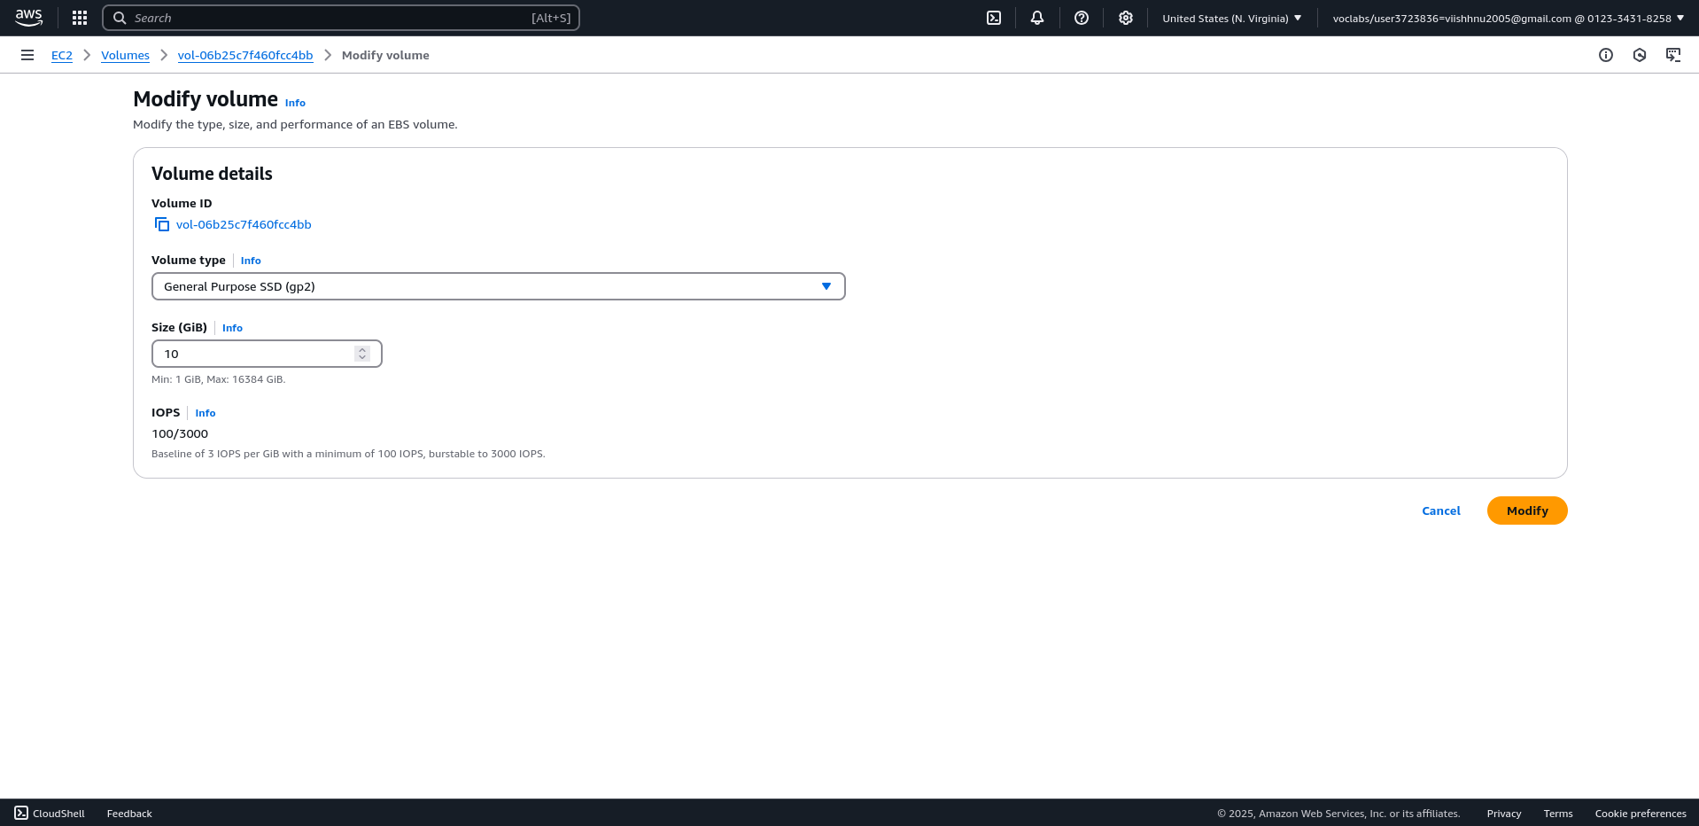

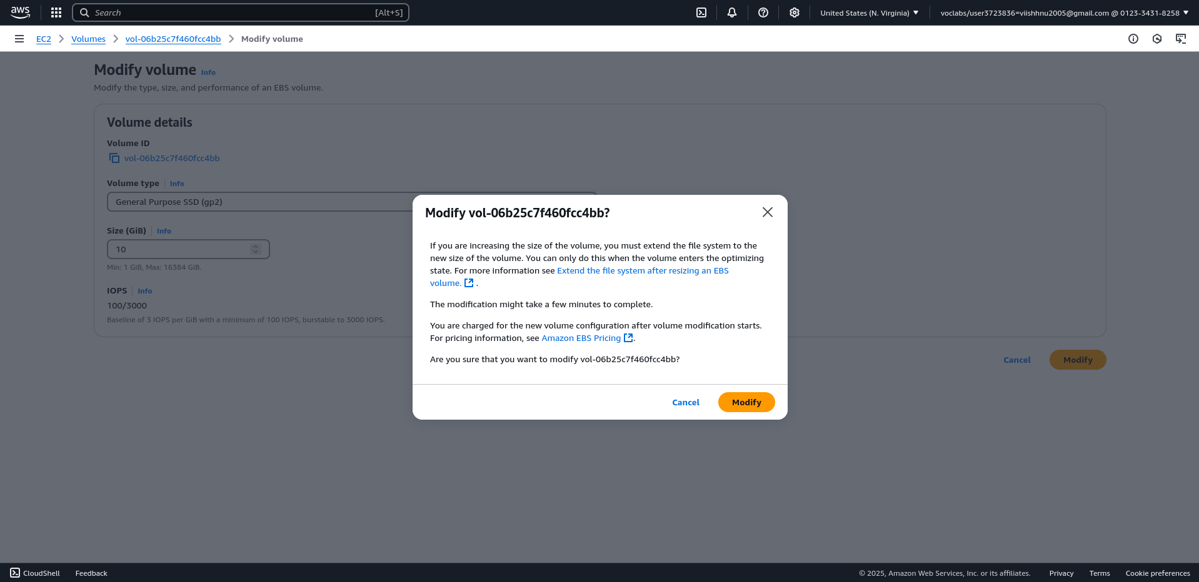

1. Connect to your instance via SSH:

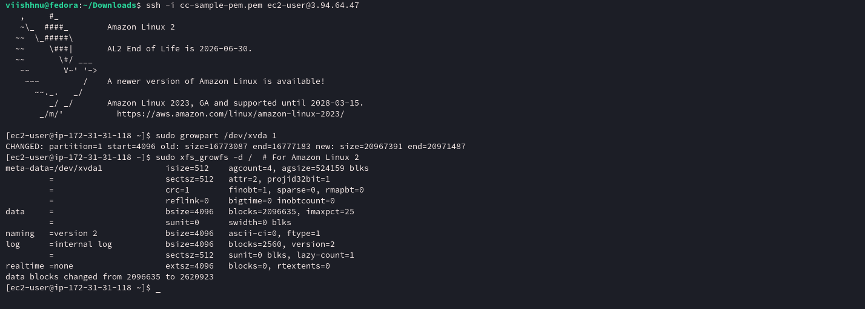

As you can see the output , the volume size increased to 10GiB

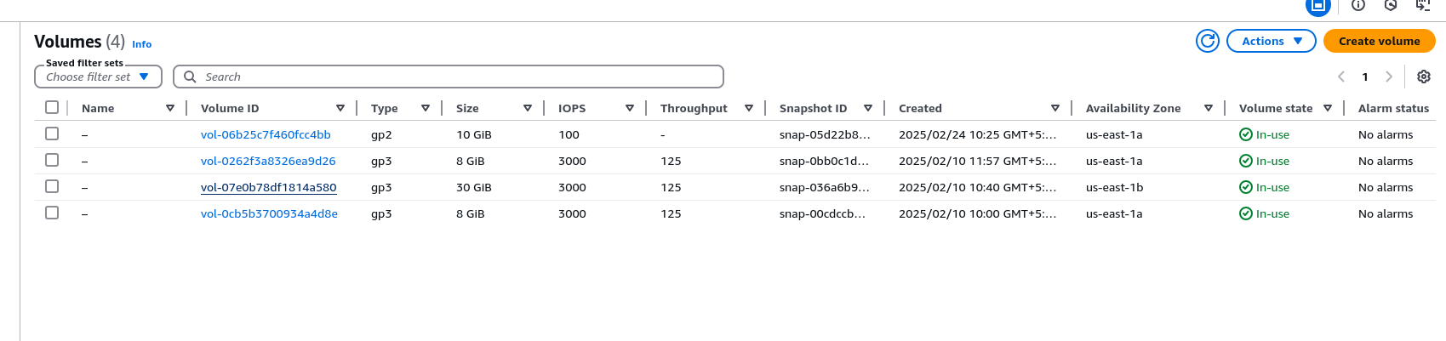

## ****Task 2: Create & Attach a New Volume (Horizontal Scaling)****

### ****Step 1: Create a New EBS Volume****

1. Go to **EC2 Dashboard** → **Volumes**.
2. Click **Create Volume**:

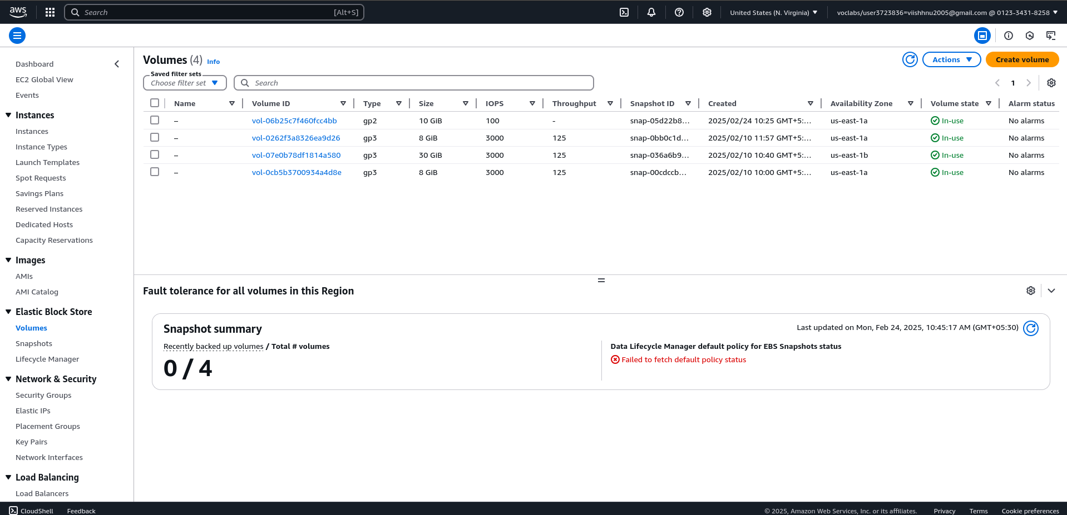

* + Choose **Size** (e.g., 10GB).
  + **Availability Zone**: Must match your EC2 instance.
  + Click **Create Volume**.

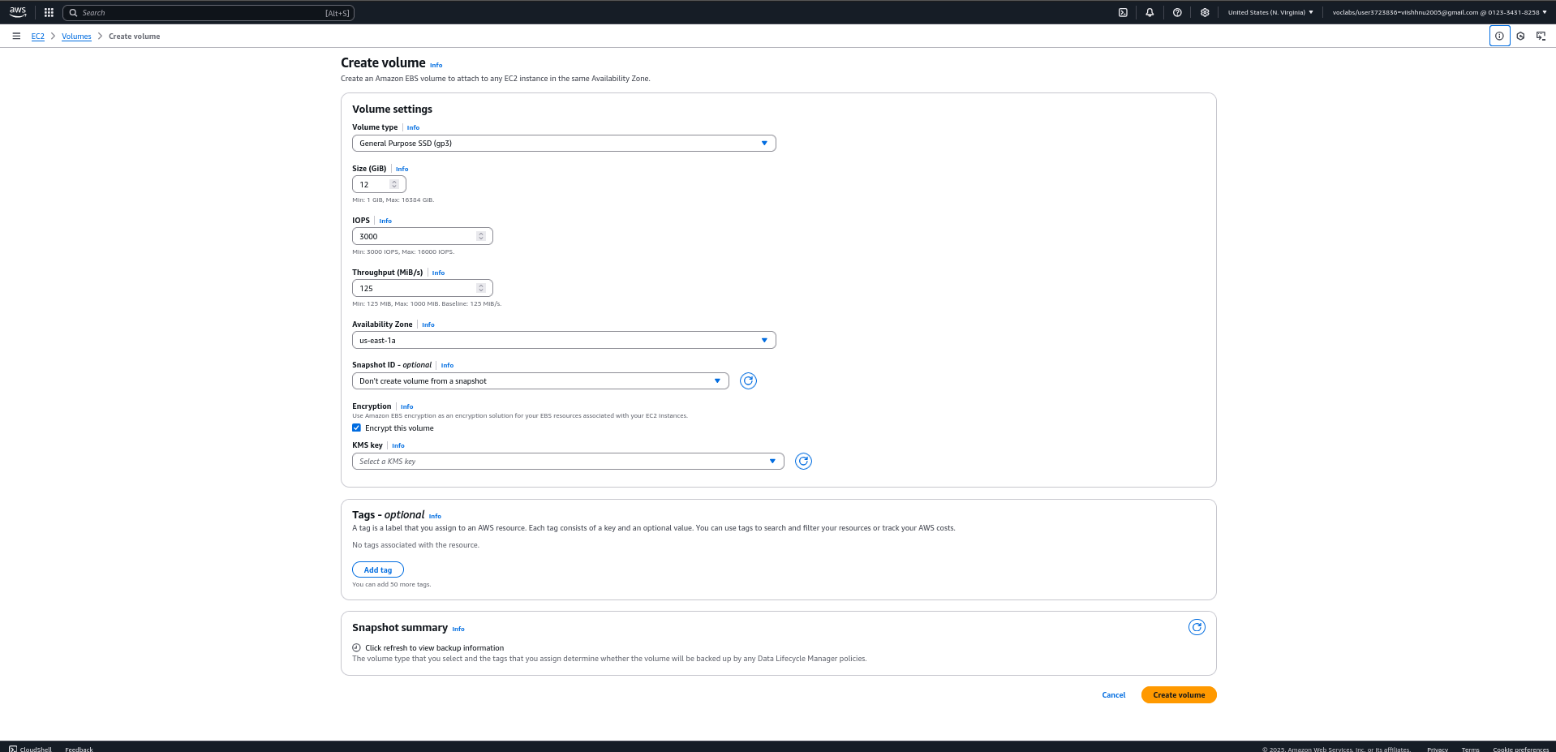

### ****Step 2: Attach the Volume to EC2****

1. Select the newly created volume.
2. Click **Actions** → **Attach Volume**.

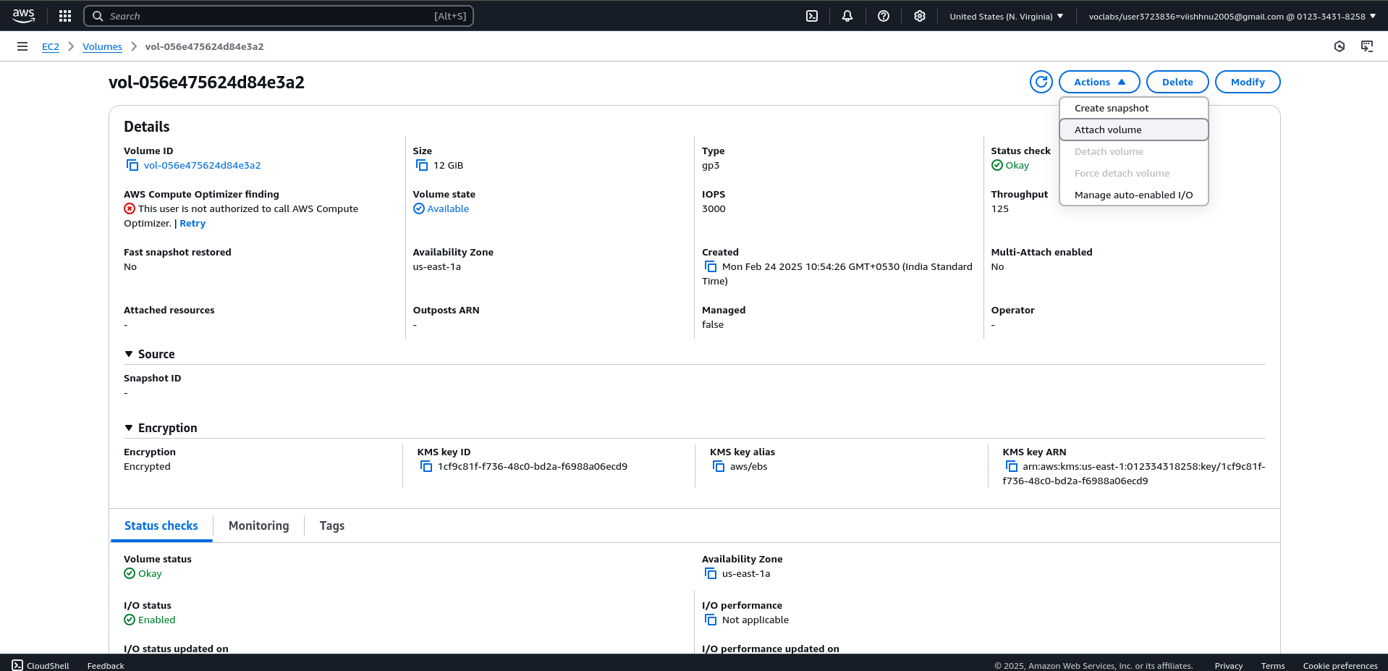

1. Choose your EC2 instance and Device Name → Attach.

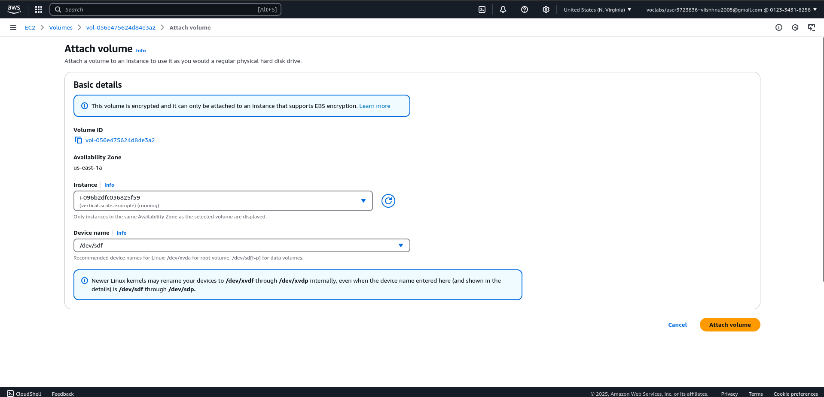

### ****Step 3: Mount the New Volume****

1. Connect to your instance via SSH.
2. List available storage devices: **lsblk**

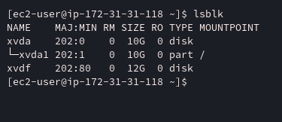

As you can see our 12GB volume is visible here xvdf (Name)

3) Format the EBS volume:

sudo mkfs -t ext4 /dev/xvdf

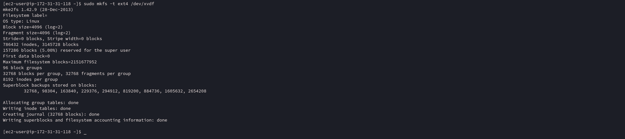

4) Create a Mount Directory and Mount the Volume

sudo mkdir /mnt/newvolume

sudo mount /dev/xvdf /mnt/newvolume

Verify using df -h it should show this parition

### ****Step 4: Create a File (Your Roll No)****

1. Navigate to the new volume:

cd /mnt/newvolume

2) sudo nano rollno.txt

add your content and save

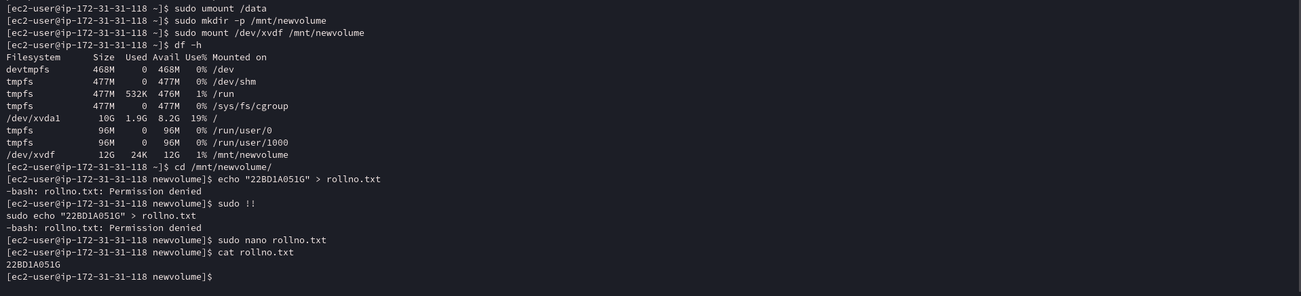

**Task 3: Detach & Attach the Volume to Another EC2 Instance**

### ****Step 1: Detach the Volume****

1. In the **EC2 Dashboard**, go to **Volumes**.
2. Select the attached volume and click **Detach Volume**.

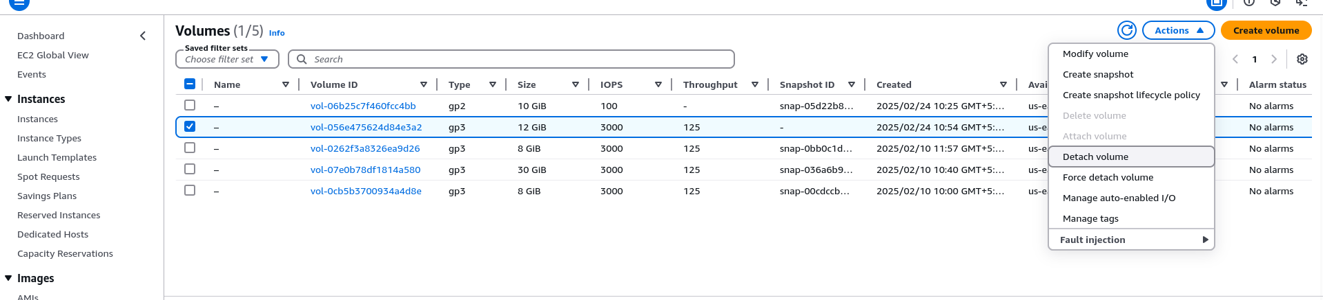

1. Wait until the status changes to **available**.

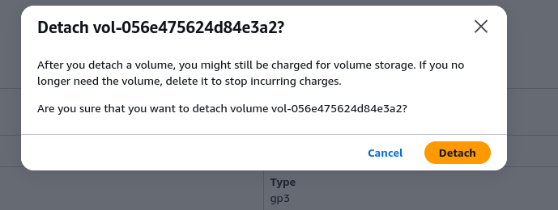

### ****Step 2: Attach to a New EC2 Instance****

1. Launch another EC2 instance (same availability zone) or use some other instance in same region.

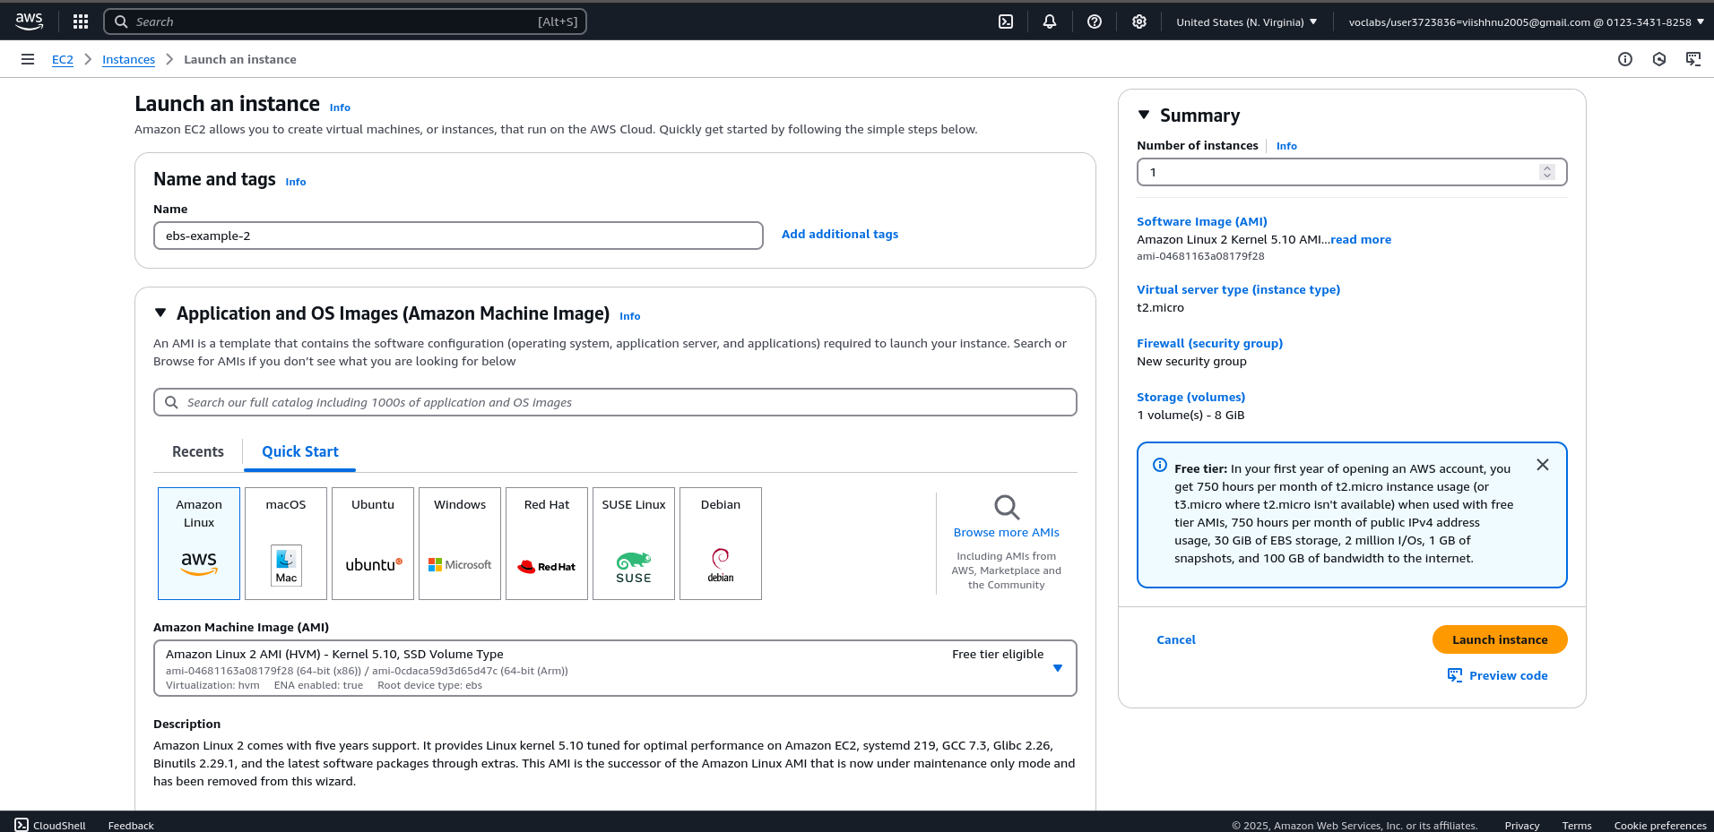

1. Go to **Volumes** → Select the detached volume.
2. Click **Attach Volume** → Choose the new EC2 instance.

**Now since my volume is encrypted I can’t directly attach it to my another EC2-instance , so what I did was I created a snapshot of my volume and created a new volume from this snapshot without any encyrption , so now I will attach this volume to my new ec2 – instance to access my rollno.txt file.**

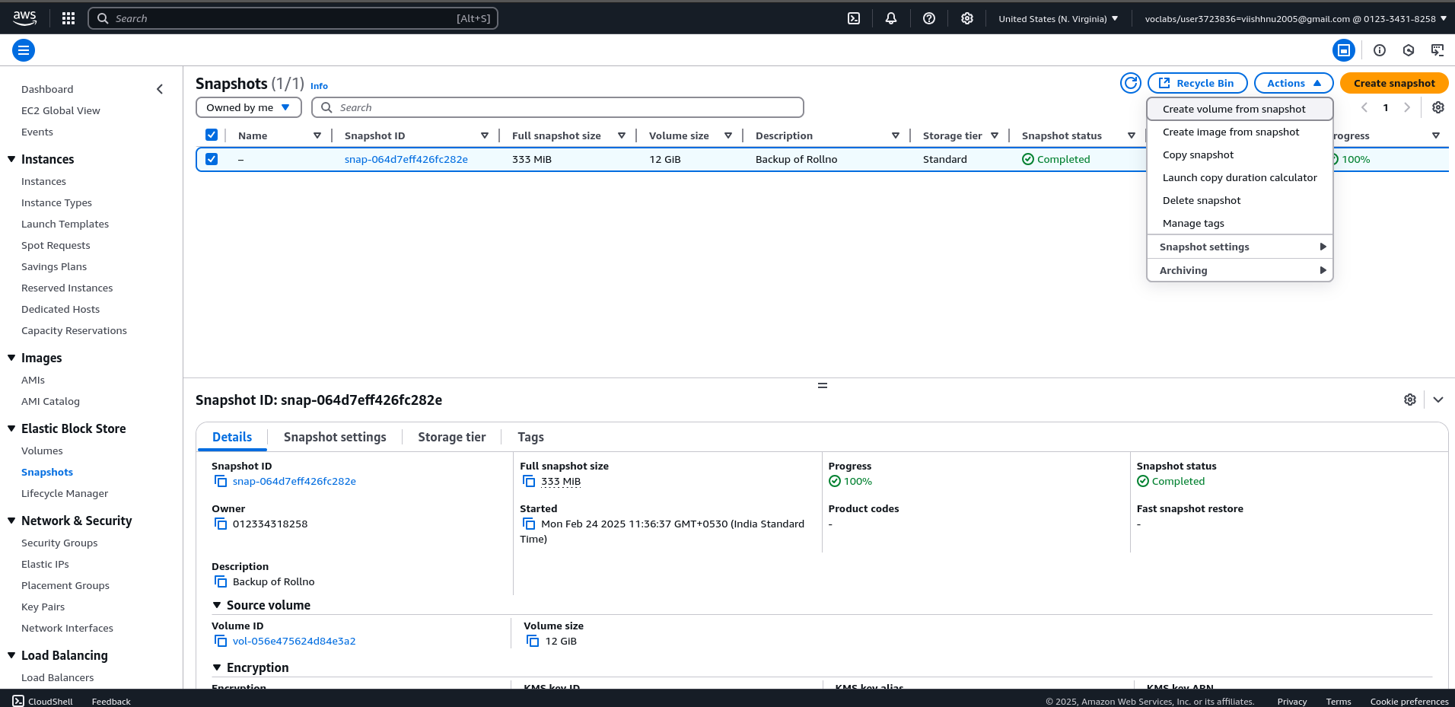

**Create a volume from my snapshot**

## ****Task 4: Create a Snapshot & Copy Across Regions****

### ****Step 1: Create a Snapshot****

1. Go to **EC2 Dashboard** → **Volumes**.
2. Select the volume you want to back up.
3. Click **Create Snapshot**.
4. Add a description (e.g., "Backup of RollNo Volume").
5. Click 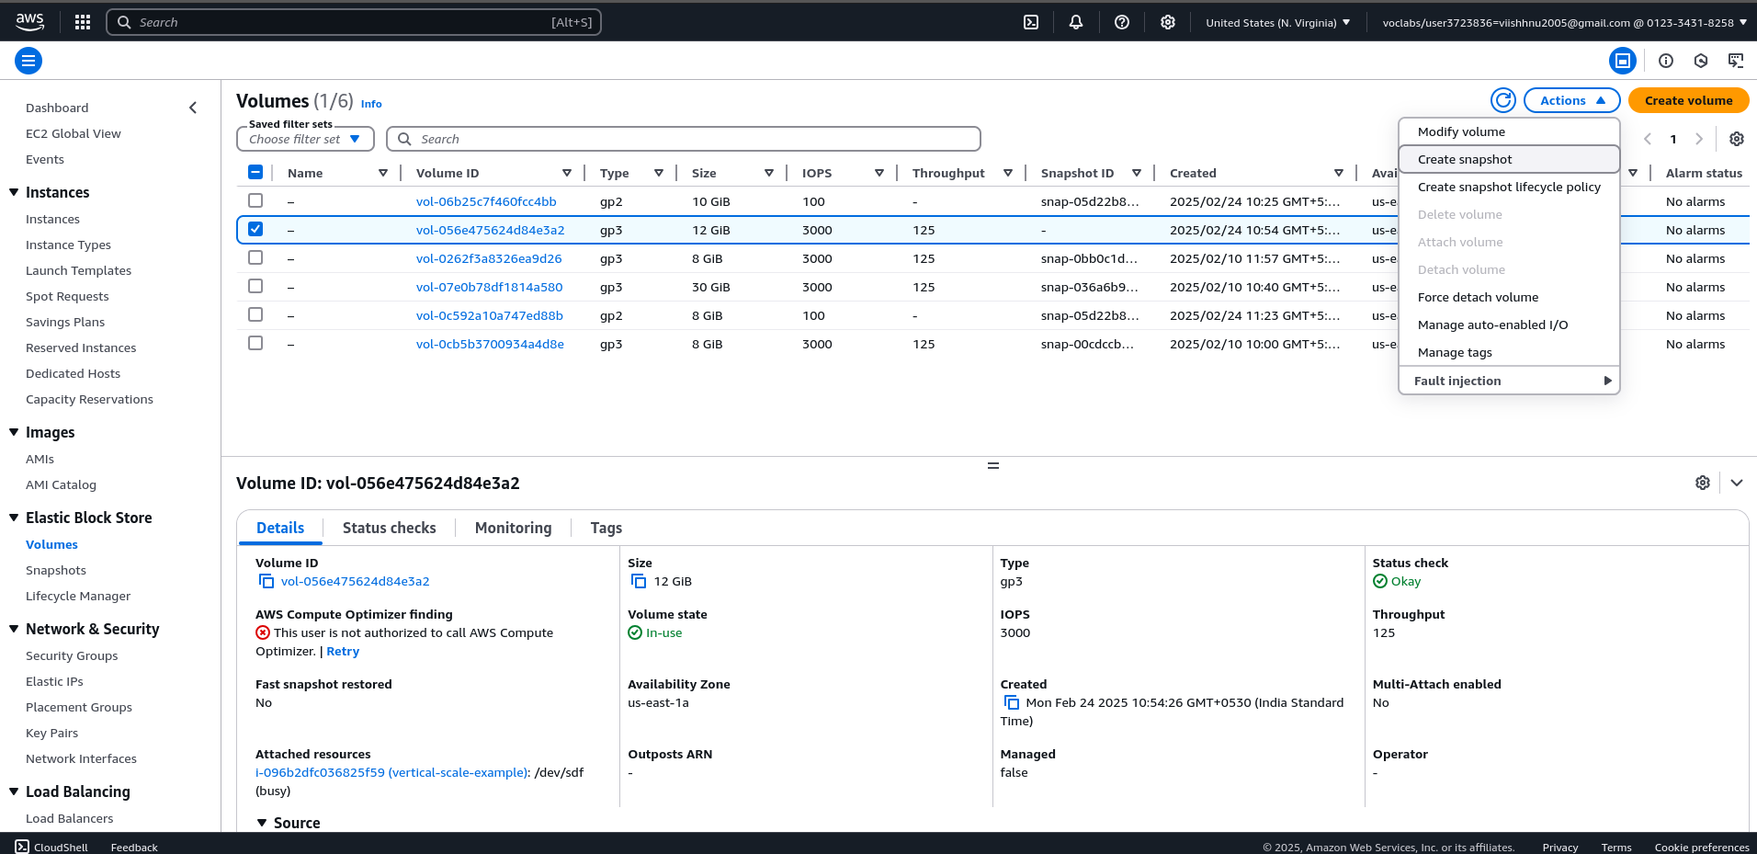**Create Snapshot**

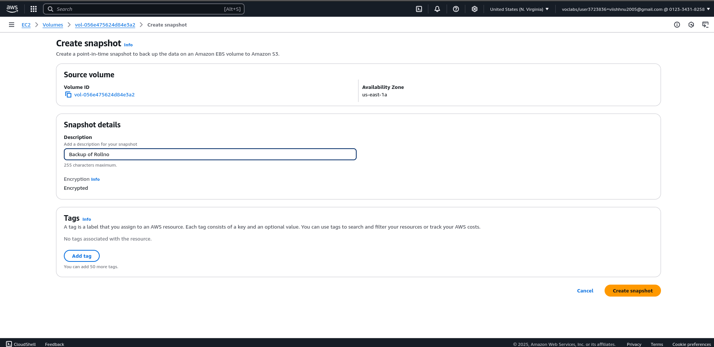

**So as you can see that the snapshot is created successfully**

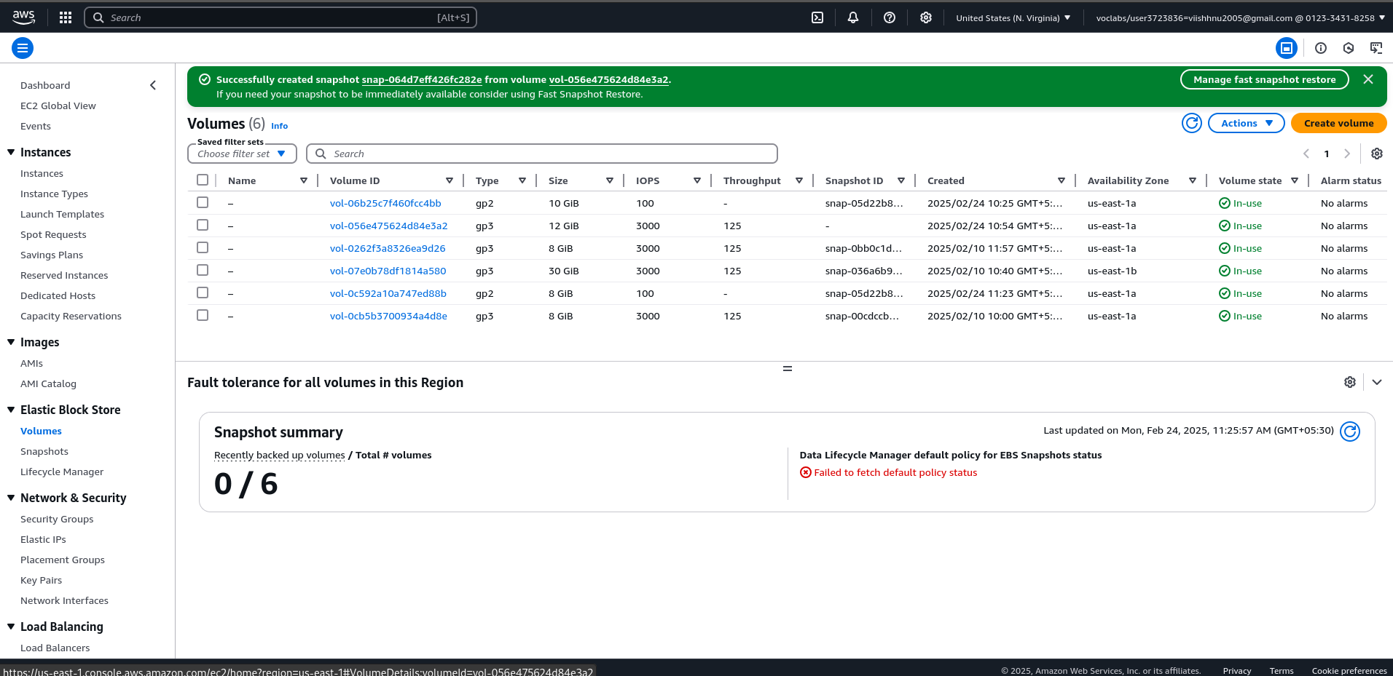

### ****Step 2: Copy Snapshot to Another Region****

1. Go to **Snapshots** → Select the snapshot.
2. Click **Actions** → **Copy Snapshot**.
3. Choose a different **destination region**.
4. Click **Copy**.

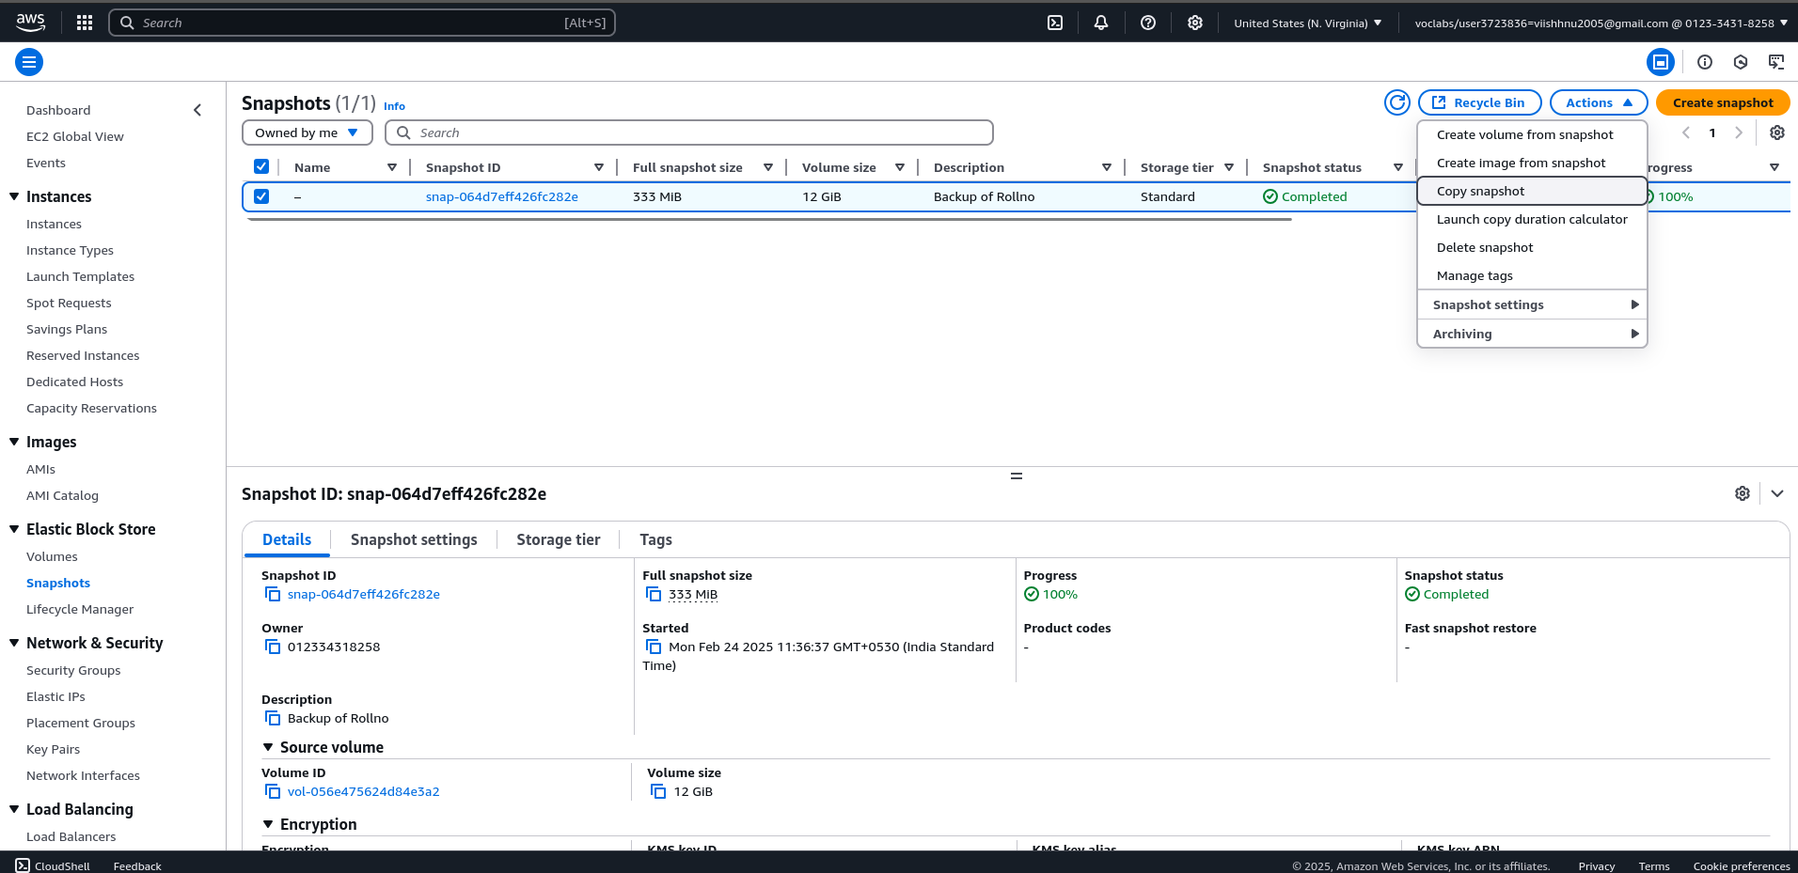

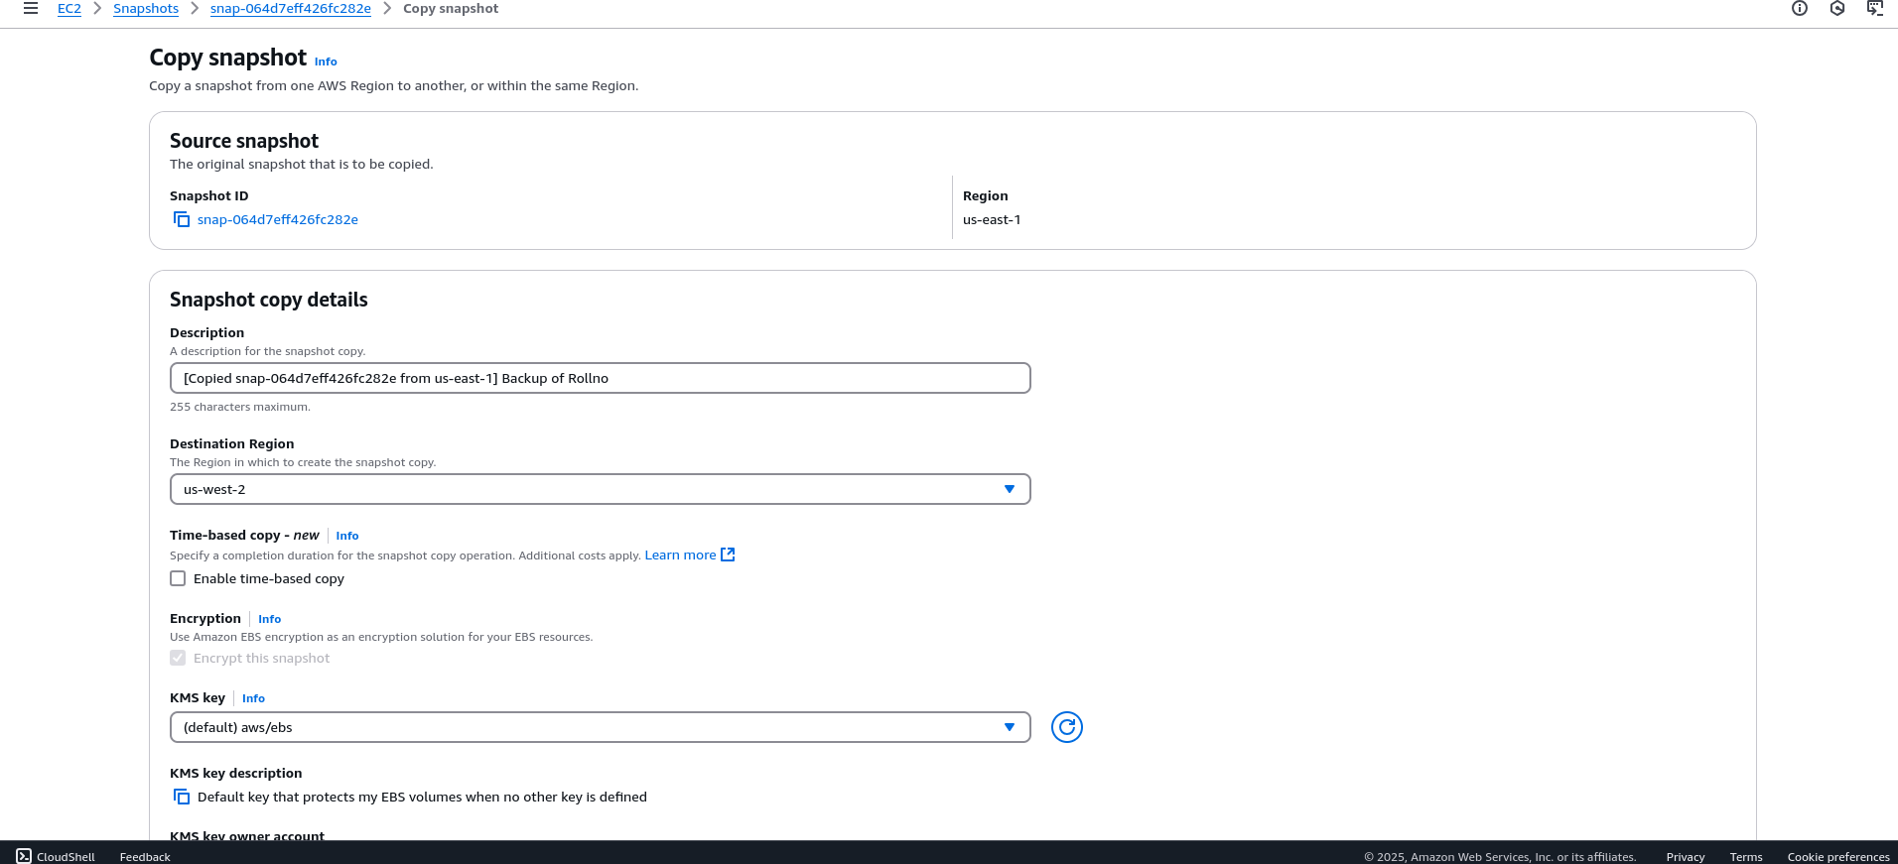**Choose region as us-west-2**

**Note:-**

**If you want to automate the process of snapshot ensure you select the enable time-based copy option ,**

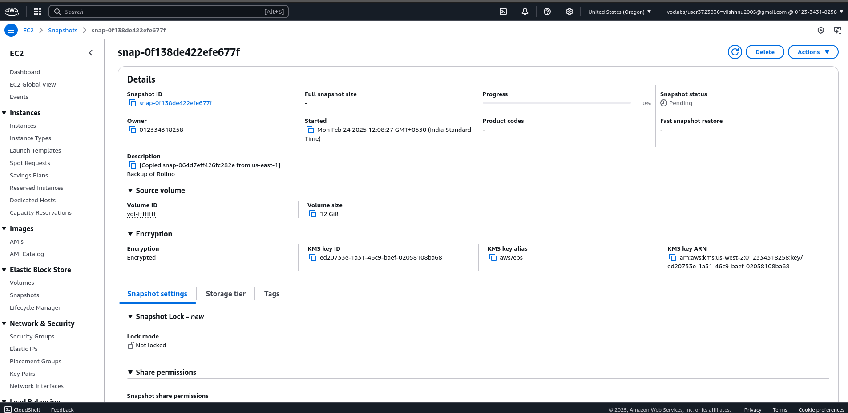

### ****Step 3: Create a New Volume from Snapshot****

1. Switch to the new region in AWS Console.
2. Go to **Snapshots** → Select the copied snapshot.
3. Click **Create Volume**.
4. Select an **availability zone** in the new region.
5. Click **Create Volume**.

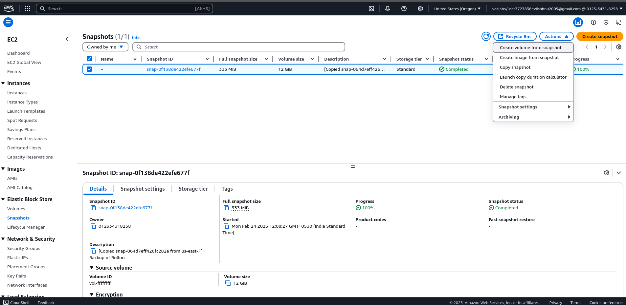

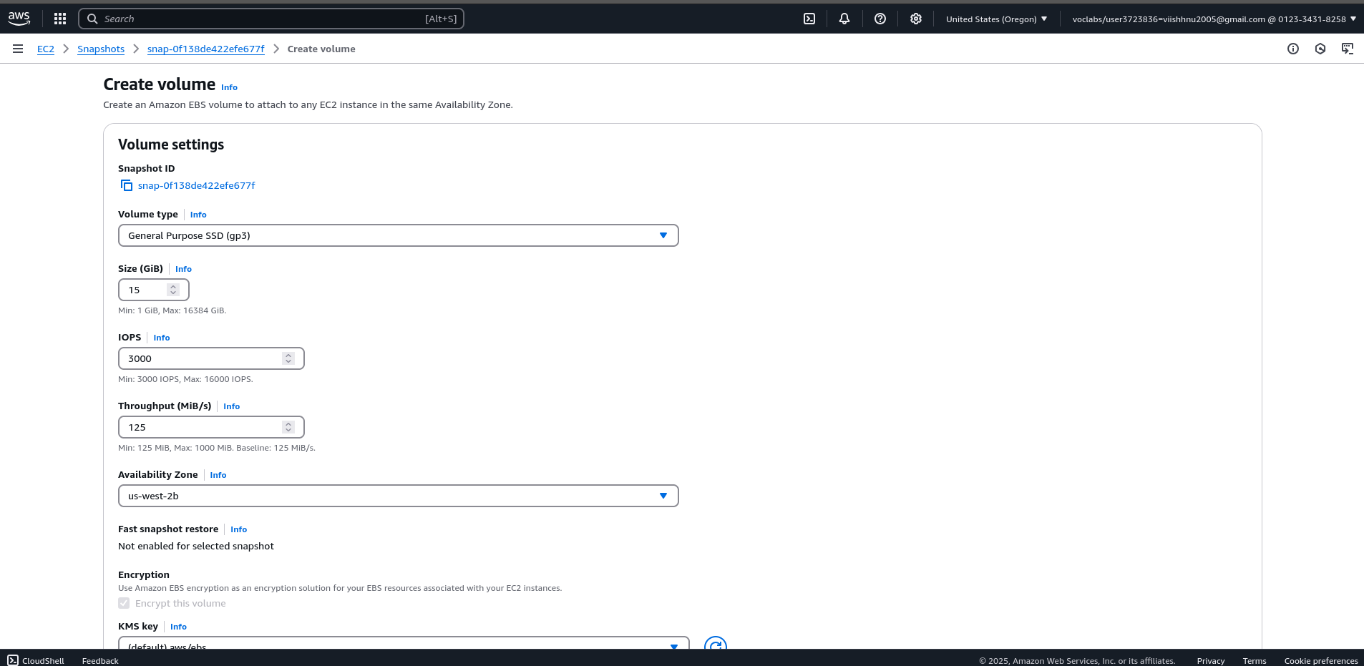

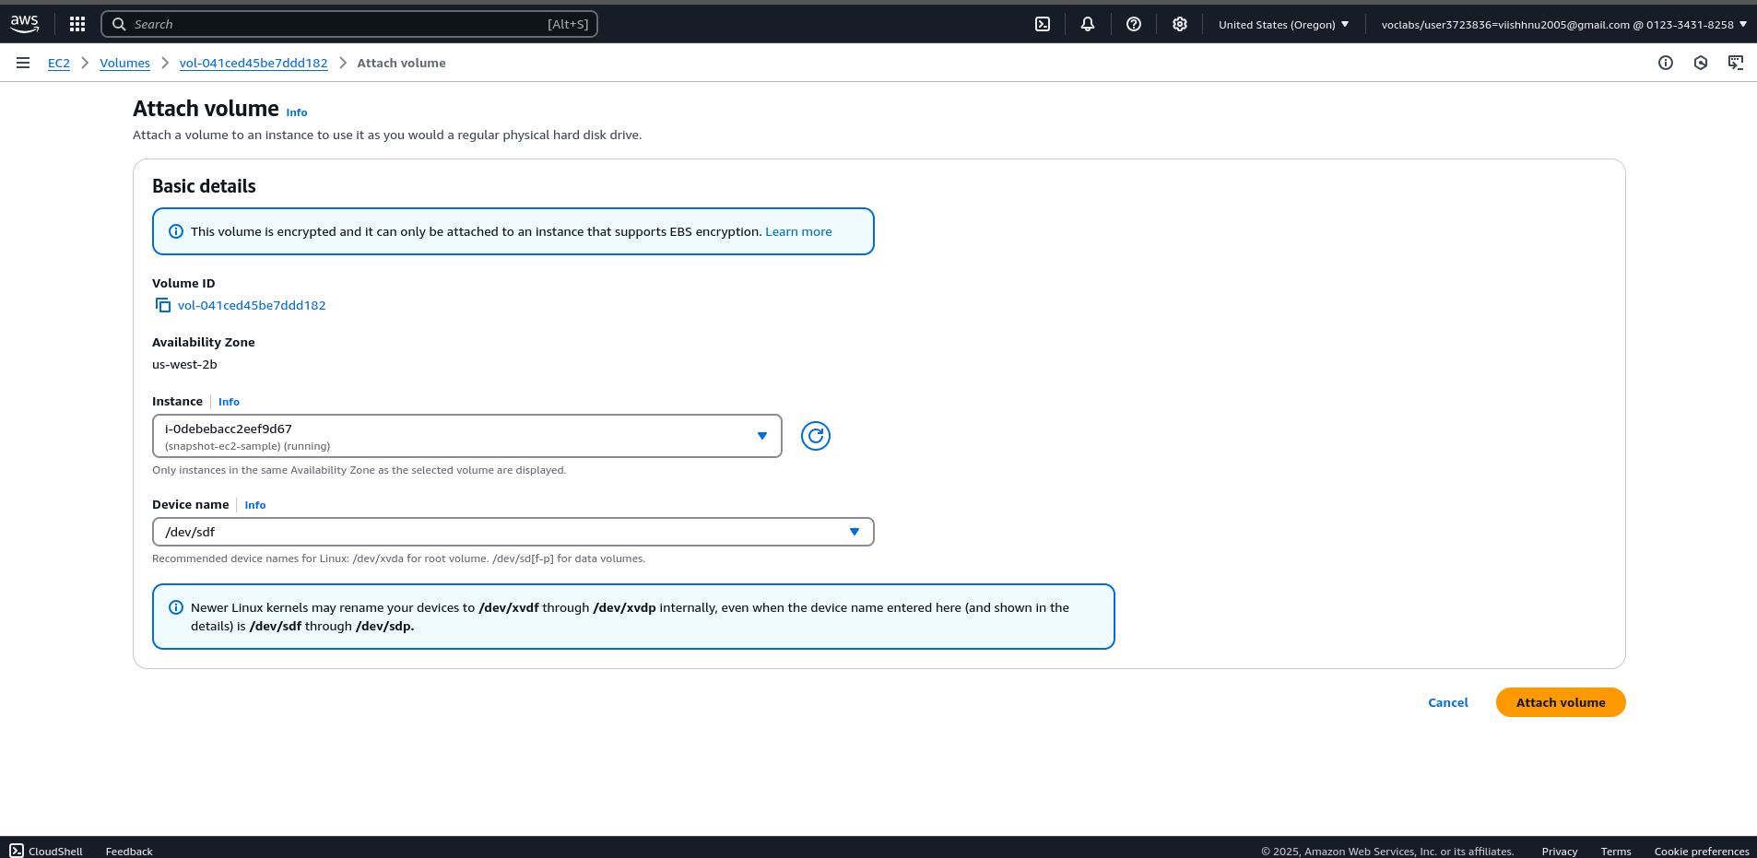

**Attack it**

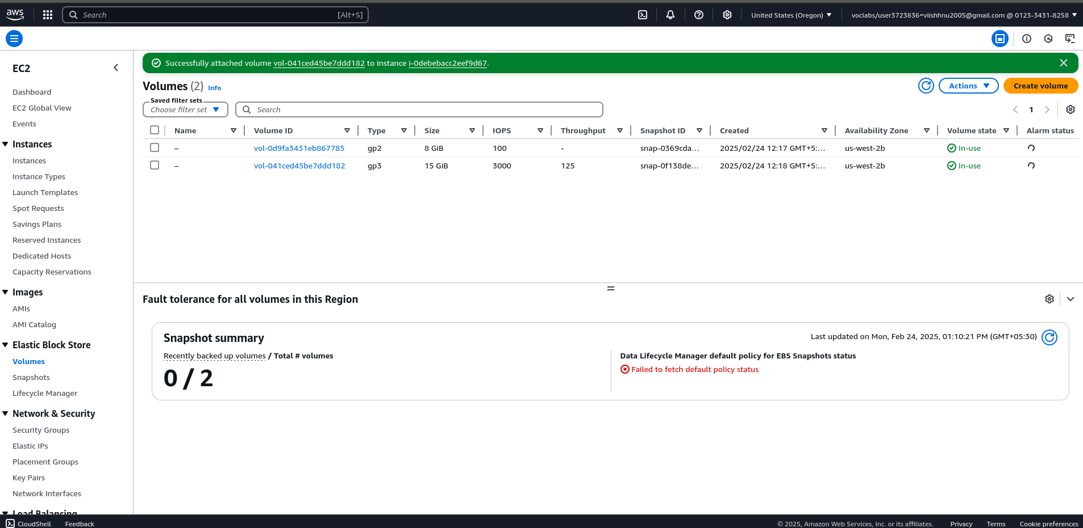

**So as you can see the rollno.txt is visible here in the another region**

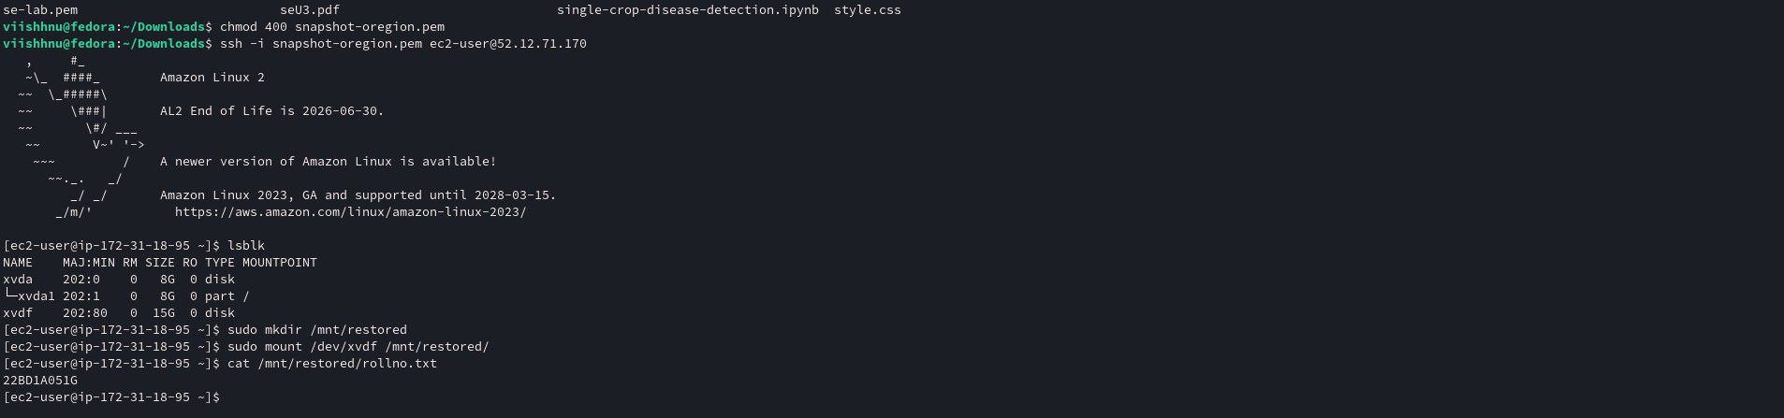

**Summary of task-4**

**Create a copy of snapshot in another region create a volume out of it , and mount the volume now you will be able to access all the contents of it previously there as seen in the above screen shot**